**Restaurant Management System**

**Aim:** To implement Restaurant Management System using JAVA and Oracle Database.

**Overview:**

The Restaurant Management System is a Java-based application designed to streamline restaurant operations by efficiently managing food items, customer bookings, food information, and billing. It provides a user-friendly interface for restaurant staff to handle reservations, order processing, and customer interactions, thereby enhancing overall efficiency and customer satisfaction.

**Technologies Used:**

- Backend: OracleDB for database management.

- Frontend: NetBeans for GUI development.

**Features:**

- Insert Food Info: Allows restaurant staff to add new food items to the menu.

- Update Food Info: Enables staff to modify existing food item details as needed.

- Delete Food Info: Facilitates the removal of outdated or unavailable food items from the menu.

Insert Food Info:

The insert food info feature enables restaurant staff to efficiently add new food items to the menu. This functionality ensures that the menu remains up-to-date and offers a variety of options to customers, enhancing their dining experience and satisfaction.

Update Food Info:

The update food info feature allows staff to modify existing food item details, such as name, description, price, and availability. This flexibility enables the restaurant to adapt to changing preferences and dietary requirements, ensuring that the menu remains relevant and appealing to customers.

Delete Food Info:

The delete food info feature enables staff to remove outdated or unavailable food items from the menu. By eliminating items that are no longer offered or in stock, this functionality helps streamline menu management and ensures that customers are presented with accurate and relevant choices

**Codes and Screenshots:**

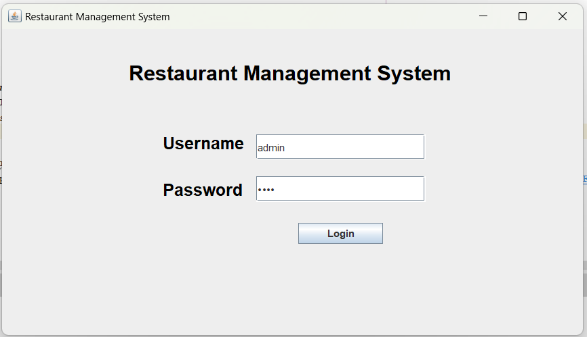**Login Page:**

package login.java;

import java.awt.*;

import java.awt.FlowLayout;

import java.awt.GridLayout;

import java.sql.Connection;

import java.sql.DriverManager;

import java.sql.PreparedStatement;

import java.sql.ResultSet;

import java.sql.SQLException;

import javax.swing.*;

import javax.swing.colorchooser.AbstractColorChooserPanel;

public class LoginJava extends JFrame{

JLabel idLabel;

JLabel passLabel;

JLabel background;

JLabel headerLabel;

JLabel devInfo;

JTextField id;

JPasswordField pass;

JButton submit;

static final String JDBC_URL = "jdbc:oracle:thin:@//localhost:1521/xe";

static final String USERNAME = "thakur";

static final String PASSWORD = "2800";

public LoginJava(){

setTitle("Restaurant Management System");

setDefaultCloseOperation(JFrame.EXIT_ON_CLOSE);

setVisible(true);

this.background = new JLabel(new ImageIcon("restaurant.jpg"));

this.init();

add(background);

background.setVisible(true);

this.pack();

this.setSize(700,400);

this.setLocationRelativeTo(null);

}

public void init(){

headerLabel = new JLabel();

this.headerLabel.setText("Restaurant Management System");

this.headerLabel.setBounds(150,1,2000,100);

this.headerLabel.setFont(new Font("Geomanist", Font.BOLD, 25));

headerLabel.setForeground(Color.black);

add(headerLabel);

idLabel = new JLabel();

this.idLabel.setText("Username");

this.idLabel.setBounds(190,110,100,50);

this.idLabel.setFont(new Font(null, Font.BOLD, 20));

idLabel.setForeground(Color.black);

add(idLabel);

passLabel=new JLabel("Password");

this.passLabel.setBounds(190,165,100,50);

this.passLabel.setFont(new Font(null, Font.BOLD, 20));

passLabel.setForeground(Color.black);

add(passLabel);

devInfo = new JLabel();

this.devInfo.setBounds(130,300,1000,30);

this.devInfo.setFont(new Font("Geomanist", Font.PLAIN, 15));

devInfo.setForeground(Color.white);

add(devInfo);

id=new JTextField();

this.id.setBounds(300,125,200,30);

add(id);

pass=new JPasswordField();

this.add(pass);

this.pass.setBounds(300,175,200,30);

this.id.setVisible(true);

this.submit=new JButton("Login");

this.submit.setBounds(350,230,100,25);

add(submit);

submit.addActionListener(this::submitActionPerformed);

}

public void submitActionPerformed(java.awt.event.ActionEvent evt){

if (evt.getSource() == submit) {

String inputUsername = id.getText();

String inputPassword = new String(pass.getPassword());

try (Connection connection = DriverManager.getConnection(JDBC_URL, USERNAME, PASSWORD)) {

String sqlQuery = "SELECT * FROM admin WHERE login_id = ? AND password = ?";

try (PreparedStatement preparedStatement = connection.prepareStatement(sqlQuery)) {

preparedStatement.setString(1, inputUsername);

preparedStatement.setString(2, inputPassword);

ResultSet resultSet = preparedStatement.executeQuery();

if (resultSet.next()) {

Home hg = new Home();

hg.showButtonDemo();

this.dispose();

} else {

JOptionPane.showMessageDialog(this, "Invalid username or password.");

}

}

} catch (SQLException ex) {

JOptionPane.showMessageDialog(this, "Error connecting to the database.");

}

}

}

public static void main(String[] args) {

LoginJava f = new LoginJava();

f.setVisible(true);

}

PreparedStatement prepareStatement(String insert_into_canteenmanagementfoodf_namef_) {

throw new UnsupportedOperationException("Not supported yet."); // Generated from nbfs://nbhost/SystemFileSystem/Templates/Classes/Code/GeneratedMethodBody

}

}

**Home Page:**

package login.java;

import java.awt.*;

import java.awt.event.*;

import java.sql.SQLException;

import java.util.logging.Level;

import java.util.logging.Logger;

import javax.swing.*;

public class Home implements ActionListener {

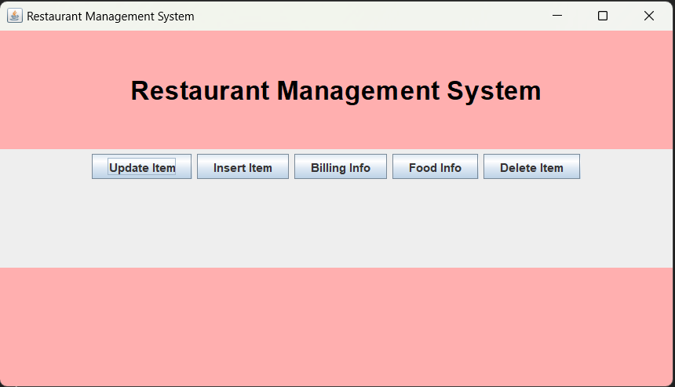 private JFrame mainFrame;

private JLabel headerLabel;

private JLabel statusLabel;

private JPanel controlPanel;

public Home() {

prepareGUI();

}

public static void main(String[] args) {

Home homeGUI = new Home();

homeGUI.showButtonDemo();

}

private void prepareGUI() {

mainFrame = new JFrame("Restaurant Management System");

mainFrame.setBounds(100, 100, 700, 400);

mainFrame.setLayout(new GridLayout(3, 1));

mainFrame.getContentPane().setBackground(Color.pink);

mainFrame.addWindowListener(new WindowAdapter() {

@Override

public void windowClosing(WindowEvent windowEvent) {

System.exit(0);

}

});

headerLabel = new JLabel("", JLabel.CENTER);

statusLabel = new JLabel("", JLabel.CENTER);

statusLabel.setSize(350, 300);

controlPanel = new JPanel();

controlPanel.setLayout(new FlowLayout());

mainFrame.add(headerLabel);

mainFrame.add(controlPanel);

mainFrame.add(statusLabel);

mainFrame.setVisible(true);

}

public void showButtonDemo() {

headerLabel.setText("Restaurant Management System");

this.headerLabel.setFont(new Font(null, Font.BOLD, 27));

headerLabel.setForeground(Color.black);

JButton fkButton = new JButton("Food Info");

JButton billButton = new JButton("Billing Info");

JButton afButton = new JButton("Insert Item");

JButton ufButton = new JButton("Update Item");

JButton dlButton = new JButton("Delete Item");

fkButton.addActionListener(new ActionListener() {

@Override

public void actionPerformed(ActionEvent e) {

// Action for Food Info button

iteminfo ii = new iteminfo();

ii.showButtonDemo();

}

});

ufButton.addActionListener(new ActionListener() {

@Override

public void actionPerformed(ActionEvent e) {

// Action for Delete Item button

UpdateFood uf = new UpdateFood();

uf.showButtonDemo();

}

});

billButton.addActionListener(new ActionListener() {

@Override

public void actionPerformed(ActionEvent e) {

// Action for Billing Info button

GenerateBill gb = new GenerateBill();

}

});

afButton.addActionListener(new ActionListener() {

@Override

public void actionPerformed(ActionEvent e) {

// Action for Insert Item button

EnterFood ef = new EnterFood();

ef.setVisible(true);

}

});

dlButton.addActionListener(new ActionListener() {

@Override

public void actionPerformed(ActionEvent e) {

// Action for Delete Item button

DeleteFood dl = new DeleteFood();

dl.showButtonDemo();

}

});

controlPanel.add(ufButton);

controlPanel.add(afButton);

controlPanel.add(billButton);

controlPanel.add(fkButton);

controlPanel.add(dlButton);

mainFrame.setVisible(true);

mainFrame.setLocationRelativeTo(null);

}

@Override

public void actionPerformed(ActionEvent e) {

throw new UnsupportedOperationException("Not supported yet."); // Generated from nbfs://nbhost/SystemFileSystem/Templates/Classes/Code/GeneratedMethodBody

}

void setVisible(boolean b) {

throw new UnsupportedOperationException("Not supported yet."); // Generated from nbfs://nbhost/SystemFileSystem/Templates/Classes/Code/GeneratedMethodBody

}

}

**Insert Item:**

package login.java;

import javax.swing.*;

import java.awt.*;

import java.awt.event.*;

import java.sql.*;

public class EnterFood extends JFrame {

private JTextField foodNameField;

private JTextField priceField;

private JTextField quantityField;

private JButton insertButton;

private JButton homeButton; // New button for home

private static final String JDBC_URL = "jdbc:oracle:thin:@//localhost:1521/XE";

private static final String USERNAME = "THAKUR";

private static final String PASSWORD = "2800";

private static final String INSERT_SQL = "INSERT INTO food (food_name, price, quantity) VALUES (?, ?, ?)";

public EnterFood() {

setTitle("Insert Food Details");

setSize(300, 200);

setDefaultCloseOperation(EXIT_ON_CLOSE);

setLocationRelativeTo(null);

JPanel panel = new JPanel();

panel.setLayout(new GridLayout(5, 2)); // Increase row count to accommodate the new button

panel.add(new JLabel("Food Name:"));

foodNameField = new JTextField();

panel.add(foodNameField);

panel.add(new JLabel("Price:"));

priceField = new JTextField();

panel.add(priceField);

panel.add(new JLabel("Quantity:"));

quantityField = new JTextField();

panel.add(quantityField);

insertButton = new JButton("Insert");

insertButton.addActionListener(new ActionListener() {

@Override

public void actionPerformed(ActionEvent e) {

insertFood();

}

});

panel.add(insertButton);

homeButton = new JButton("Home"); // Create Home button

homeButton.addActionListener(new ActionListener() {

@Override

public void actionPerformed(ActionEvent e) {

// Add functionality to return to home

dispose(); // Close the current window

// Open the home window or frame

// For simplicity, let's assume there's a class named HomeFrame for the home window

Home homeFrame = new Home();

homeFrame.setVisible(true);

}

});

panel.add(homeButton); // Add Home button to the panel

add(panel);

}

private void insertFood() {

String foodName = foodNameField.getText();

double price = Double.parseDouble(priceField.getText());

int quantity = Integer.parseInt(quantityField.getText());

try (Connection connection = DriverManager.getConnection(JDBC_URL, USERNAME, PASSWORD);

PreparedStatement preparedStatement = connection.prepareStatement(INSERT_SQL)) {

preparedStatement.setString(1, foodName);

preparedStatement.setDouble(2, price);

preparedStatement.setInt(3, quantity);

int rowsInserted = preparedStatement.executeUpdate();

if (rowsInserted > 0) {

JOptionPane.showMessageDialog(this, "Food details inserted successfully.");

foodNameField.setText("");

priceField.setText("");

quantityField.setText("");

} else {

JOptionPane.showMessageDialog(this, "Failed to insert food details.");

}

} catch (SQLException ex) {

ex.printStackTrace();

JOptionPane.showMessageDialog(this, "Error: " + ex.getMessage());

}

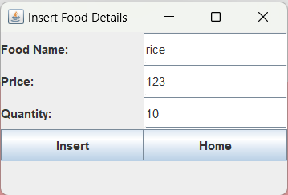 }

public static void main(String[] args) {

SwingUtilities.invokeLater(new Runnable() {

@Override

public void run() {

new EnterFood().setVisible(true);

}

});

}

}

**Update Item:**

package login.java;

import java.awt.*;

import java.awt.event.*;

import javax.swing.*;

import java.sql.*;

public class UpdateFood {

private JFrame mainFrame;

private JLabel headerLabel;

private JLabel statusLabel;

private JPanel controlPanel;

private JLabel name, price, quantity;

GridLayout experimentLayout = new GridLayout(0, 2);

ResultSet rs;

UpdateFood() {

prepareGUI();

}

public static void main(String[] args) {

UpdateFood swingControlDemo = new UpdateFood();

swingControlDemo.showButtonDemo();

}

private void prepareGUI() {

mainFrame = new JFrame("Update!");

mainFrame.setSize(700, 400);

mainFrame.setLayout(new GridLayout(3, 1));

mainFrame.getContentPane().setBackground(Color.pink);

mainFrame.addWindowListener(new WindowAdapter() {

@Override

public void windowClosing(WindowEvent windowEvent) {

mainFrame.setVisible(false);

}

});

headerLabel = new JLabel("", JLabel.CENTER);

statusLabel = new JLabel("", JLabel.CENTER);

statusLabel.setSize(350, 400);

controlPanel = new JPanel();

controlPanel.setLayout(new FlowLayout());

mainFrame.add(headerLabel);

mainFrame.add(controlPanel);

mainFrame.add(statusLabel);

mainFrame.setVisible(true);

}

public void showButtonDemo() {

headerLabel.setText("Restaurant Management System");

headerLabel.setFont(new Font(null, Font.BOLD, 27));

name = new JLabel("Enter Name");

JTextField tf2 = new JTextField();

tf2.setSize(100, 30);

price = new JLabel("Enter Price");

JTextField tf3 = new JTextField();

tf3.setSize(100, 30);

quantity = new JLabel("Enter Quantity");

JTextField tf4 = new JTextField();

tf4.setSize(100, 30);

JButton okButton = new JButton("UPDATE");

okButton.addActionListener(new ActionListener() {

@Override

public void actionPerformed(ActionEvent e) {

PreparedStatement pst;

Connection con = null;

try {

Class.forName("oracle.jdbc.driver.OracleDriver");

con = DriverManager.getConnection("jdbc:oracle:thin:@//localhost:1521/XE", "THAKUR", "2800");

pst = con.prepareStatement("UPDATE food SET quantity = ?, price = ? WHERE food_name = ?");

pst.setInt(1, Integer.parseInt(tf4.getText()));

pst.setDouble(2, Double.parseDouble(tf3.getText()));

pst.setString(3, tf2.getText());

pst.executeUpdate();

JOptionPane.showMessageDialog(null, "Done Updating " + tf2.getText());

mainFrame.setVisible(false);

} catch (Exception ex) {

System.out.println(ex);

JOptionPane.showMessageDialog(null, "Error: " + ex.getMessage());

} finally {

try {

if (con != null) {

con.close();

}

} catch (SQLException ex) {

System.out.println(ex);

}

}

}

});

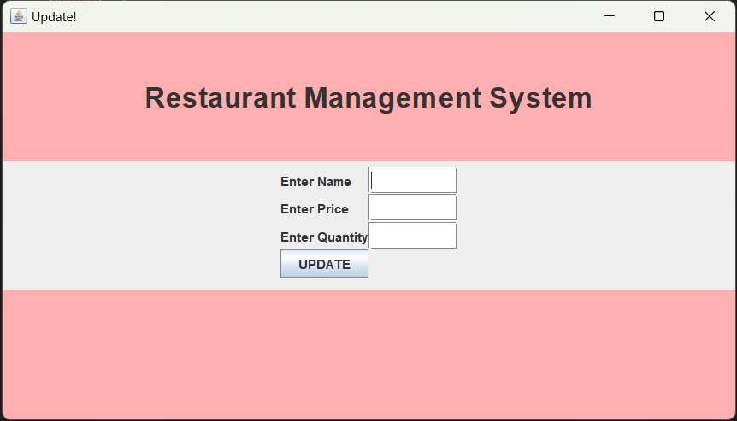 JPanel jp = new JPanel();

jp.add(name);

jp.add(tf2);

jp.add(price);

jp.add(tf3);

jp.add(quantity);

jp.add(tf4);

jp.setSize(200, 200);

jp.setLayout(experimentLayout);

controlPanel.add(jp);

jp.add(okButton);

mainFrame.setVisible(true);

mainFrame.setLocationRelativeTo(null);

}

}

**Item Info:**

package login.java;

import java.awt.*;

import java.awt.event.*;

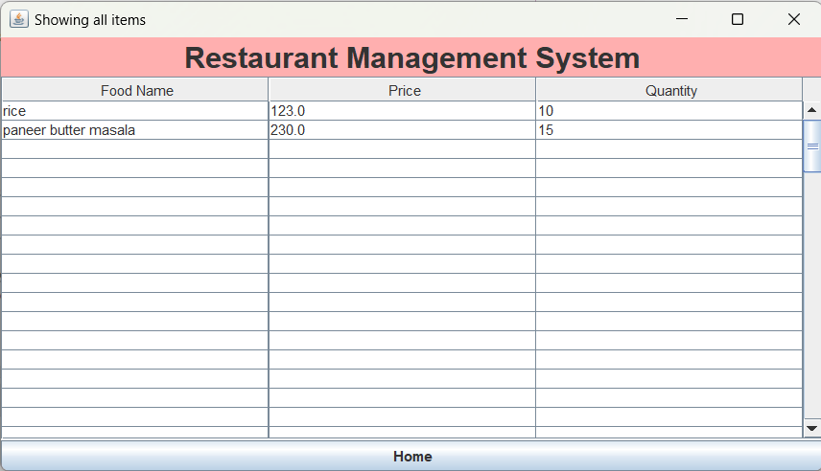import java.sql.*;

import javax.swing.*;

public class iteminfo {

private JFrame mainFrame;

private JLabel headerLabel;

private JPanel controlPanel;

iteminfo() {

prepareGUI();

}

public static void main(String[] args) {

iteminfo swingControlDemo = new iteminfo();

swingControlDemo.showButtonDemo();

}

private void prepareGUI() {

mainFrame = new JFrame("Showing all items");

mainFrame.setSize(700, 400);

mainFrame.getContentPane().setBackground(Color.pink);

mainFrame.setLayout(new BorderLayout());

mainFrame.addWindowListener(new WindowAdapter() {

public void windowClosing(WindowEvent windowEvent) {

System.exit(0);

}

});

headerLabel = new JLabel("", JLabel.CENTER);

controlPanel = new JPanel();

controlPanel.setLayout(new BorderLayout());

mainFrame.add(headerLabel, BorderLayout.NORTH);

mainFrame.add(controlPanel, BorderLayout.CENTER);

mainFrame.setVisible(true);

}

public void showButtonDemo() {

headerLabel.setText("Restaurant Management System");

headerLabel.setFont(new Font(null, Font.BOLD, 25));

String[] columnNames = {"Food Name", "Price", "Quantity"};

Object[][] data = new Object[100][3]; // Assuming 100 rows

try {

// Connect to Oracle database

Connection connection = DriverManager.getConnection("jdbc:oracle:thin:@//localhost:1521/XE", "THAKUR", "2800");

// Execute query to retrieve data from the "food" table

PreparedStatement pst = connection.prepareStatement("SELECT * FROM food");

ResultSet rs = pst.executeQuery();

int i = 0;

while (rs.next()) {

// Fetch data from ResultSet

data[i][0] = rs.getString("food_name");

data[i][1] = rs.getDouble("price");

data[i][2] = rs.getInt("quantity");

i++;

}

// Close the resources

rs.close();

pst.close();

connection.close();

} catch (SQLException ex) {

ex.printStackTrace();

JOptionPane.showMessageDialog(null, "Error!");

}

// Create JTable and display the retrieved data

JTable table = new JTable(data, columnNames);

table.setPreferredScrollableViewportSize(new Dimension(500, 70));

table.setFillsViewportHeight(true);

controlPanel.removeAll(); // Clear existing content

controlPanel.add(new JScrollPane(table), BorderLayout.CENTER);

// Add home button

JButton homeButton = new JButton("Home");

homeButton.addActionListener(new ActionListener() {

@Override

public void actionPerformed(ActionEvent e) {

// Perform action when home button is clicked

// You can define the action to navigate back to the home screen here

// For now, let's just display a message

dispose(); // Close the current window

// Open the home window or frame

// For simplicity, let's assume there's a class named HomeFrame for the home window

Home homeFrame = new Home();

homeFrame.setVisible(true);

}

private void dispose() {

throw new UnsupportedOperationException("Not supported yet."); // Generated from nbfs://nbhost/SystemFileSystem/Templates/Classes/Code/GeneratedMethodBody

}

});

controlPanel.add(homeButton, BorderLayout.SOUTH);

mainFrame.setVisible(true);

mainFrame.setLocationRelativeTo(null);

}

void setVisible(boolean b) {

throw new UnsupportedOperationException("Not supported yet."); // Generated from nbfs://nbhost/SystemFileSystem/Templates/Classes/Code/GeneratedMethodBody

}

}

**Delete Item:**

package login.java;

import java.awt.*;

import java.awt.event.*;

import javax.swing.*;

import java.sql.*;

public class DeleteFood {

private JFrame mainFrame;

private JLabel headerLabel;

private JPanel controlPanel;

private JLabel nameLabel; // Changed to better represent the purpose

DeleteFood() {

prepareGUI();

}

public static void main(String[] args) {

DeleteFood swingControlDemo = new DeleteFood();

swingControlDemo.showButtonDemo();

}

private void prepareGUI() {

mainFrame = new JFrame("Delete Food Item");

mainFrame.setSize(400, 200);

mainFrame.getContentPane().setBackground(Color.pink);

mainFrame.setLayout(new GridLayout(3, 1));

mainFrame.addWindowListener(new WindowAdapter() {

@Override

public void windowClosing(WindowEvent windowEvent) {

mainFrame.setVisible(false);

}

});

headerLabel = new JLabel("Restaurant Management System", JLabel.CENTER);

headerLabel.setFont(new Font(null, Font.BOLD, 18));

controlPanel = new JPanel();

controlPanel.setLayout(new FlowLayout());

mainFrame.add(headerLabel);

mainFrame.add(controlPanel);

mainFrame.setVisible(true);

}

public void showButtonDemo() {

nameLabel = new JLabel("Enter Food Name:");

JTextField nameTextField = new JTextField(20);

JButton deleteButton = new JButton("Delete");

deleteButton.addActionListener(new ActionListener() {

@Override

public void actionPerformed(ActionEvent e) {

String foodName = nameTextField.getText();

if (foodName.isEmpty()) {

JOptionPane.showMessageDialog(mainFrame, "Please enter a food name to delete.");

return;

}

try (Connection connection = DriverManager.getConnection("jdbc:oracle:thin:@//localhost:1521/XE", "THAKUR", "2800")) {

PreparedStatement preparedStatement = connection.prepareStatement("DELETE FROM food WHERE food_name = ?");

preparedStatement.setString(1, foodName);

int rowsAffected = preparedStatement.executeUpdate();

if (rowsAffected > 0) {

JOptionPane.showMessageDialog(mainFrame, "Food item '" + foodName + "' deleted successfully.");

nameTextField.setText("");

} else {

JOptionPane.showMessageDialog(mainFrame, "No such food item found: " + foodName);

}

} catch (SQLException ex) {

ex.printStackTrace();

JOptionPane.showMessageDialog(mainFrame, "Error: " + ex.getMessage());

}

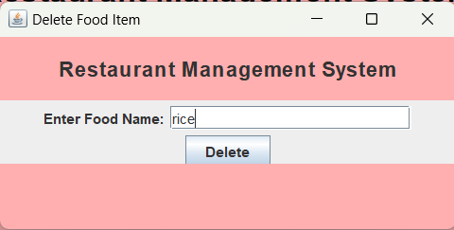 }

});

controlPanel.add(nameLabel);

controlPanel.add(nameTextField);

controlPanel.add(deleteButton);

mainFrame.setLocationRelativeTo(null);

}

}

**Billing Info:**

package login.java;

import java.awt.*;

import java.awt.event.*;

import java.sql.*;

import java.util.ArrayList;

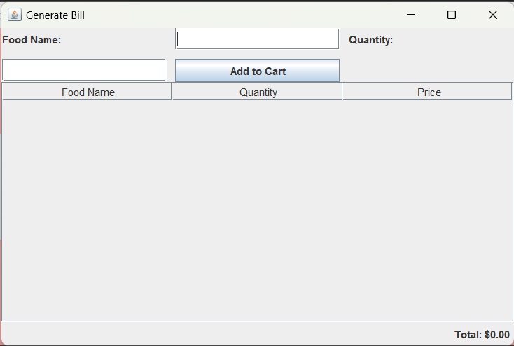import javax.swing.*;

import javax.swing.table.DefaultTableModel;

public class GenerateBill extends JFrame {

JTextField foodField, quantityField;

JLabel totalLabel;

JTable cartTable;

DefaultTableModel cartModel;

double totalAmount = 0;

ArrayList<FoodCart> foodList = new ArrayList<>();

GenerateBill() {

setTitle("Generate Bill");

setLayout(new BorderLayout());

setDefaultCloseOperation(EXIT_ON_CLOSE);

setSize(600, 400);

setLocationRelativeTo(null);

JPanel inputPanel = new JPanel(new GridLayout(2, 2, 10, 10));

JLabel foodLabel = new JLabel("Food Name:");

foodField = new JTextField();

JLabel quantityLabel = new JLabel("Quantity:");

quantityField = new JTextField();

inputPanel.add(foodLabel);

inputPanel.add(foodField);

inputPanel.add(quantityLabel);

inputPanel.add(quantityField);

JButton addButton = new JButton("Add to Cart");

addButton.addActionListener(new ActionListener() {

public void actionPerformed(ActionEvent e) {

addToCart();

}

});

inputPanel.add(addButton);

add(inputPanel, BorderLayout.NORTH);

cartModel = new DefaultTableModel(new Object[]{"Food Name", "Quantity", "Price"}, 0);

cartTable = new JTable(cartModel);

JScrollPane scrollPane = new JScrollPane(cartTable);

add(scrollPane, BorderLayout.CENTER);

JPanel totalPanel = new JPanel(new FlowLayout(FlowLayout.RIGHT));

totalLabel = new JLabel("Total: $0.00");

totalPanel.add(totalLabel);

add(totalPanel, BorderLayout.SOUTH);

setVisible(true);

}

private void addToCart() {

String foodName = foodField.getText().trim();

String quantityStr = quantityField.getText().trim();

if (foodName.isEmpty() || quantityStr.isEmpty()) {

JOptionPane.showMessageDialog(this, "Please enter food name and quantity.");

return;

}

try {

int quantity = Integer.parseInt(quantityStr);

PreparedStatement pst;

Connection connection = DriverManager.getConnection("jdbc:oracle:thin:@//localhost:1521/XE", "THAKUR", "2800");

pst = connection.prepareStatement("SELECT f_prize FROM canteenmanagement.food WHERE f_name = ?");

pst.setString(1, foodName);

ResultSet rs = pst.executeQuery();

if (rs.next()) {

double price = rs.getDouble("f_prize");

double total = price * quantity;

totalAmount += total;

FoodCart foodItem = new FoodCart(foodName, quantity, total);

foodList.add(foodItem);

cartModel.addRow(new Object[]{foodName, quantity, total});

updateTotalLabel();

} else {

JOptionPane.showMessageDialog(this, "Food not found in the database.");

}

connection.close();

} catch (NumberFormatException | SQLException ex) {

ex.printStackTrace();

JOptionPane.showMessageDialog(this, "Error: " + ex.getMessage());

}

}

private void updateTotalLabel() {

totalLabel.setText("Total: $" + String.format("%.2f", totalAmount));

}

public static void main(String[] args) {

SwingUtilities.invokeLater(new Runnable() {

public void run() {

new GenerateBill();

}

});

}

class FoodCart {

String name;

int quantity;

double totalPrice;

public FoodCart(String name, int quantity, double totalPrice) {

this.name = name;

this.quantity = quantity;

this.totalPrice = totalPrice;

}

}

}

**Database:**

